Amey Kelekar

[INFO6350](https://blackboard.neu.edu/webapps/blackboard/execute/launcher?type=Course&id=_2455988_1&url=)

Assignment 7

03/27/2016

1. **Flow of the assignment:**

Hospital ----> List of Patients

Person ----> address

Patient extends Person, Patient ----> Medical record

1. **Functionalities:**
2. A/a -- Create and add a patient
3. U/u -- Update Patient
4. D/d -- Delete Patient
5. S/s -- Search a patient in the entire hospital
6. L/l -- List of patients
7. E/e -- Exit the application
8. **Output Screen shots:**

Main Screen:



Adding a new patient









Selecting photos for user profile:





Search a patient:

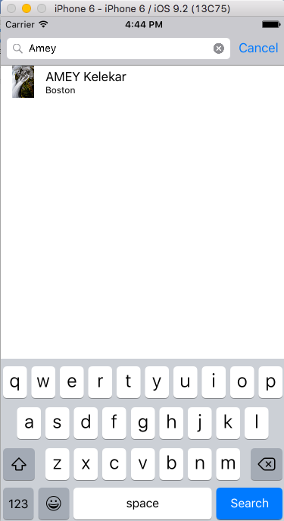

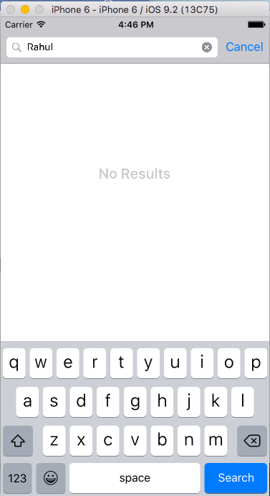

List a patient:



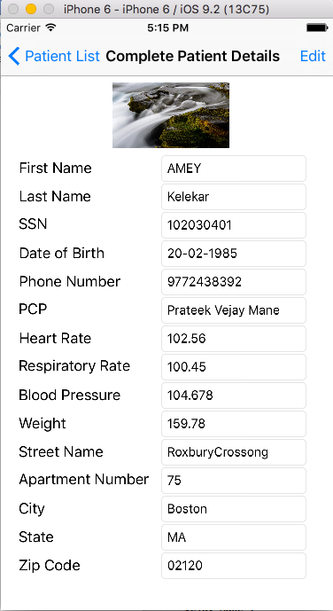

Update Patient: (Click edit button to update patient, save button appears and then edit and save)





After updating:

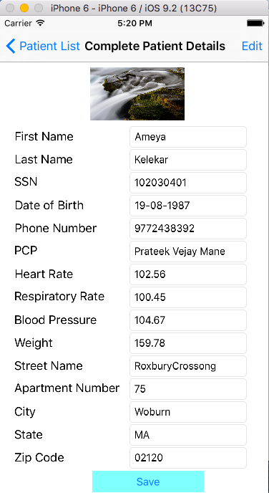

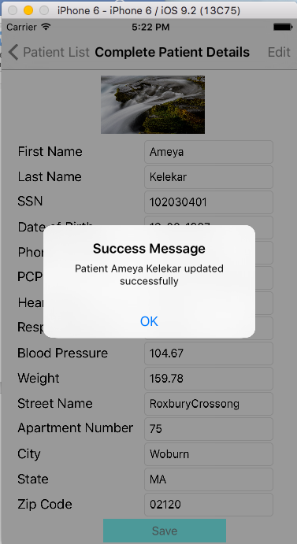

Delete Patient: (Slide on patient name and delete button will appear)

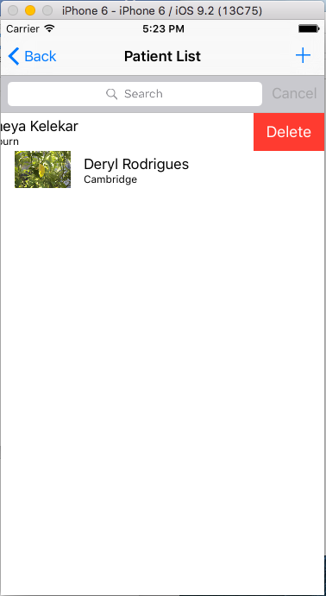

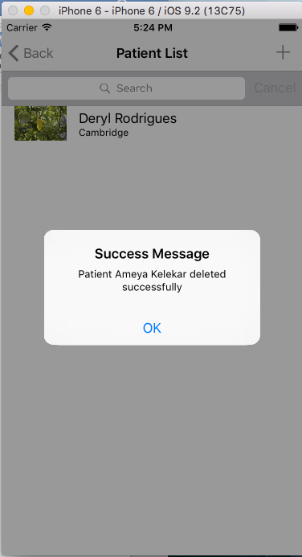

Exit the application:

